***Unix Assignment Questions***

Step 1: Set Up WSL and Ubuntu

### Enable WSL:

### Open PowerShell as Administrator and run:

### wsl --install

### This will enable WSL and install the default Linux distribution (usually Ubuntu).

### Open Ubuntu:

### After installation, search for "Ubuntu" in the Start menu and open it.

### Complete the setup by entering a username and password when prompted.

### Update and Upgrade:

### Run the following commands to update the system:

### sudo apt update && sudo apt upgrade -y

### **Basic File Operations:**

**Q1: Create a new directory called project in your home directory. Inside the project directory, create two subdirectories named src and bin.**



* mkdir is used to create directories.
* ~ refers to your home directory.

**Q2: Create a text file named notes.txt in the src directory and add some text into it using the echo command. Display the contents of the file.**

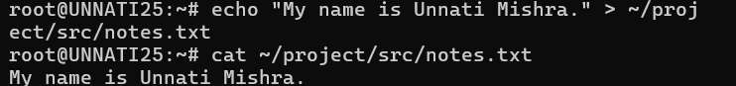

* echo writes the given text.
* directs the output to a file (creates or overwrites it).
* cat display the contents of notes.txt

### **2. Working with File Permissions:**

**Q3: Create a file named data.txt. Set the permissions so that:**

* + **The owner can read and write.**
  + **The group can read.**
  + **Others have no permissions.**



* touch creates an empty file.
* chmod 640 sets permissions:
* Owner: read/write (6 = 4 + 2).
* Group: read-only (4).
* Others: no permissions (0).

**Q4: Change the permissions of data.txt to be readable, writable, and executable by everyone.**



chmod 777 grants all permissions to everyone.

### **3. File Searching and Manipulation:**

**Q5: Using the find command, search for all .txt files in your home directory.**

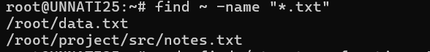

The find command searches for files that match the specified criteria (in this case, all .txt files) starting from the home directory (~). The -name "*.txt" flag filters files by the .txt extension.

**Q6: Find all files in the /etc directory that were last modified in the last 7 days.**

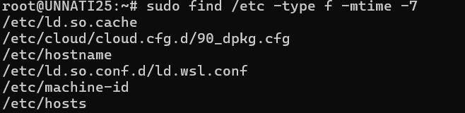

The find command with -mtime -7 searches for files in /etc that have been modified within the last 7 days. The -mtime option allows specifying time-based conditions for file modification.

**Q7: Use the grep command to search for the word "error" in the /var/log/syslog file. Display the lines where this word occurs.**

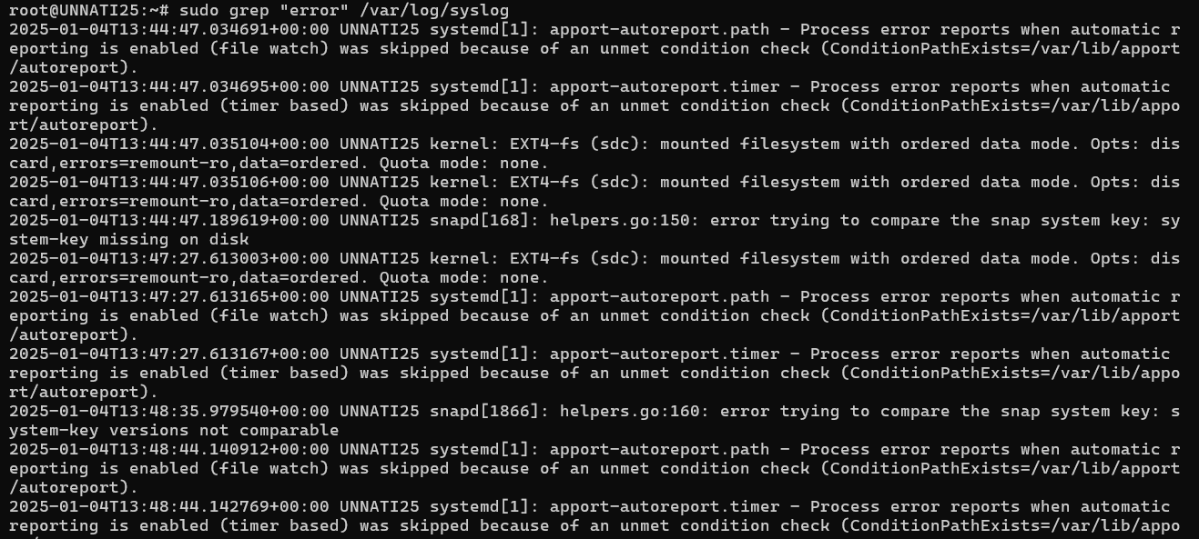

The grep command searches for the specified string ("error") in the syslog file located in /var/log. Using sudo ensures access to system logs, which often require elevated privileges.

### **4. Text File Operations:**

**Q8: Display the contents of a file report.txt line by line using the cat, more, and less commands.**

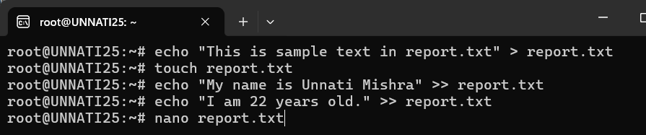

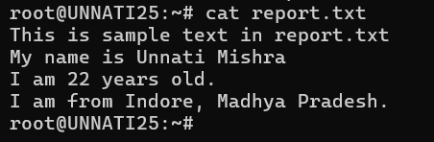

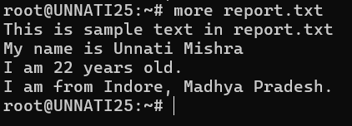

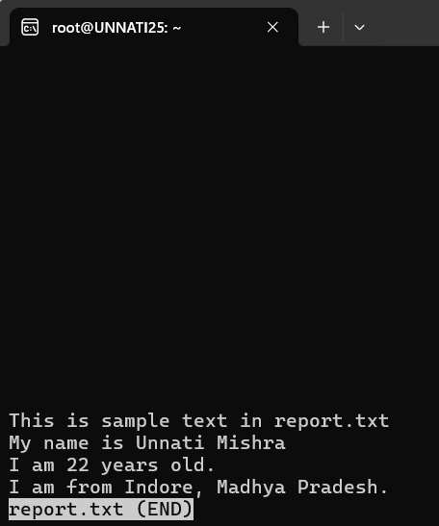

The cat, more, and less commands display the contents of report.txt. cat prints the entire file, while more and less allow for paginated viewing, with less offering more interactive navigation options.

**Q9: Use head and tail commands to display the first 10 and last 10 lines of a file named log.txt.**

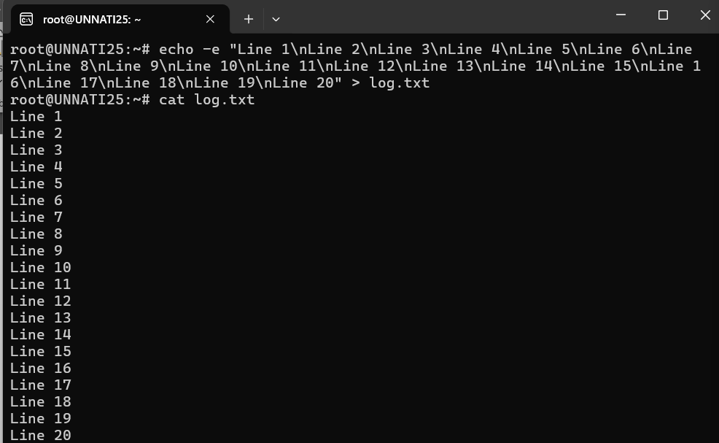

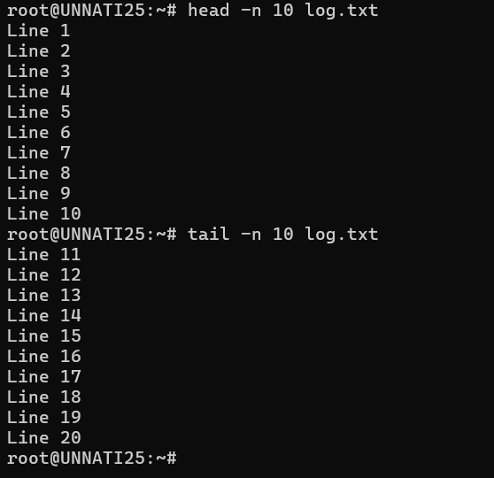

The head command shows the first 10 lines, and the tail command shows the last 10 lines of the specified file. These are useful for quickly checking the beginning or end of a file without opening it fully.

**Q10: Create a file named names.txt containing a list of names. Use sort to display the names in alphabetical order.**

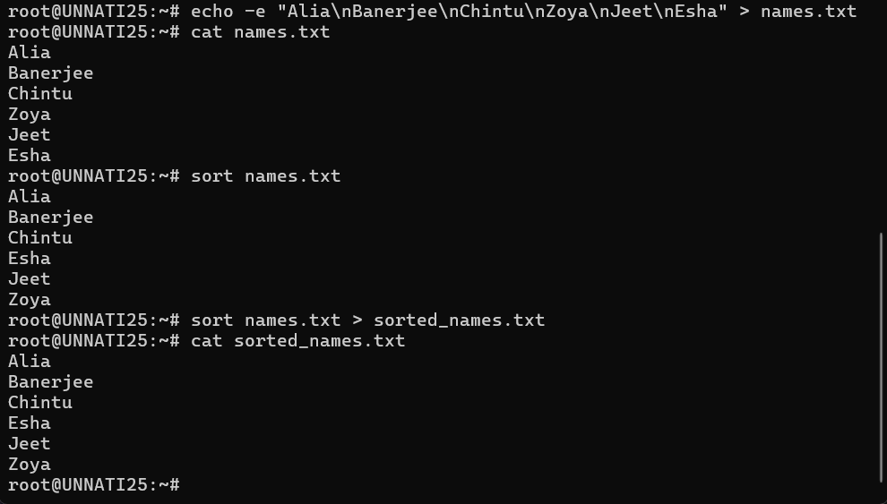

The echo command creates a file names.txt with a list of names, and the sort command arranges them in alphabetical order.

**Q11: Use the wc command to count the number of words, lines, and characters in a file data.csv.**

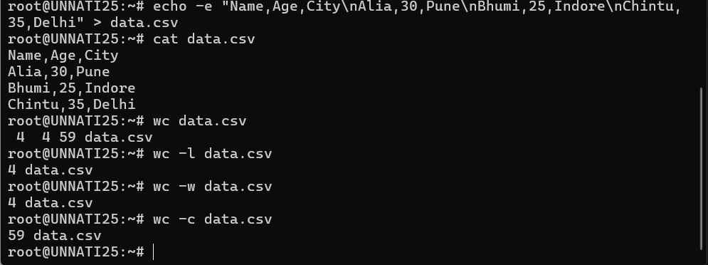

The wc (word count) command provides the number of lines, words, and characters in a specified file, helping with basic file statistics.

wc is the word count utility.

Options:

-l: Count lines.

-w: Count words.

-c: Count characters.

### **5. Process Management:**

**Q12: List all running processes using the ps command.**

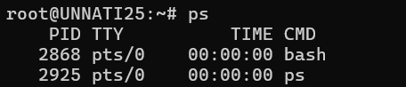

The ps command, when run without options, displays a snapshot of the current processes running for the current user in the current terminal session. The output includes the process ID (PID), terminal, time, and the command that started the process.

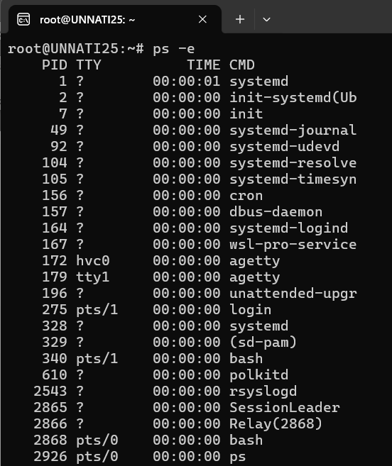

The -e option shows all processes running on the system, not just those for the current user or session. It lists every process running on the machine, including background processes and system processes.

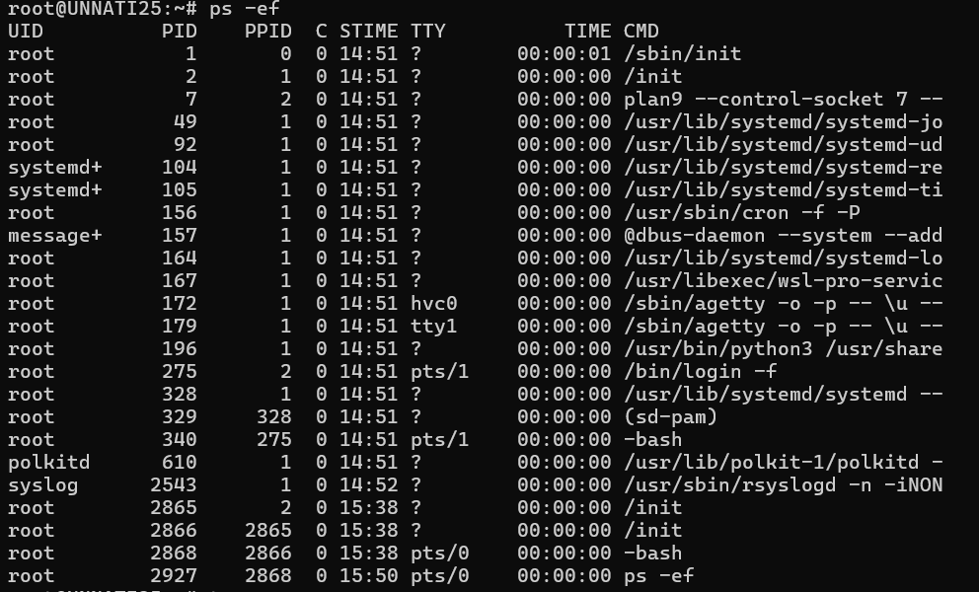

The ps -ef command is used to display a full list of all running processes on a Linux or Unix-like system with detailed information.

-f: This option provides a "full" listing, including additional details like the parent process ID (PPID), the user who started the process, the start time of the process, and the full command line used to start the process.

**6. System Information:**

**Q13: Display the current date and time using the date command.**



The date command displays the current system date and time. It's commonly used to verify time settings or log timestamps.

**Q14: Use the df command to display disk space usage.**

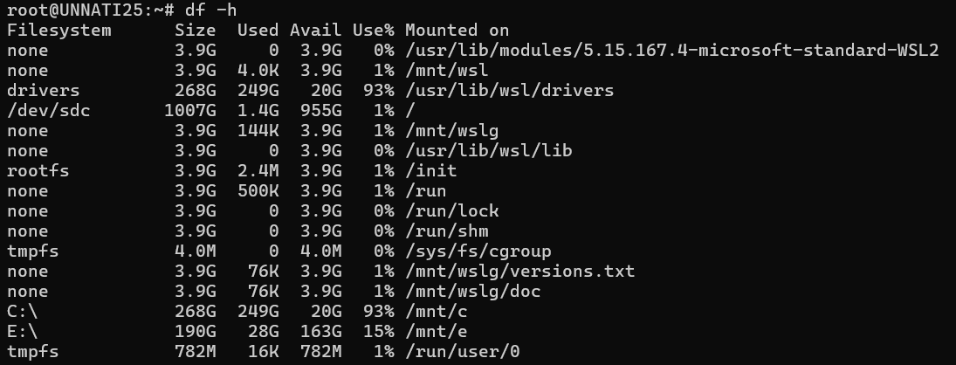

The df -h command shows the disk usage of all mounted filesystems in human-readable format (e.g., GB, MB).

**Q15: Use the uname command to display your system’s information (e.g., OS type, version).**



The uname -a command outputs detailed information about the system, including the kernel name, version, architecture, and hostname.

**Q16: Display the current system uptime using the uptime command.**

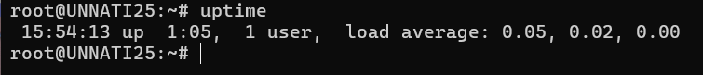

The uptime command shows how long the system has been running since the last boot, along with system load averages.

### **7. Network Commands:**

**Q17: Use the ping command to check if a remote server (e.g., google.com) is reachable.**

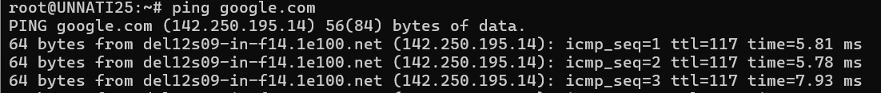



The ping command checks the reachability of a remote server (in this case, google.com) by sending ICMP echo requests and waiting for responses.

**Q18: Use the ifconfig or ip a command to display the network configuration of your system.**

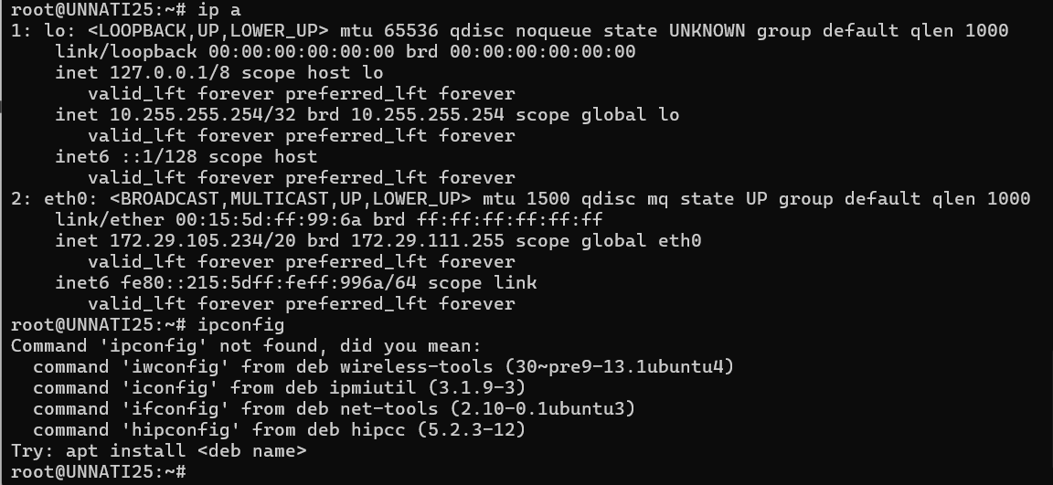

The ip a command shows detailed information about all network interfaces on the system, such as IP addresses and connection statuses.

**Q19: Display the active network connections using the netstat command.**

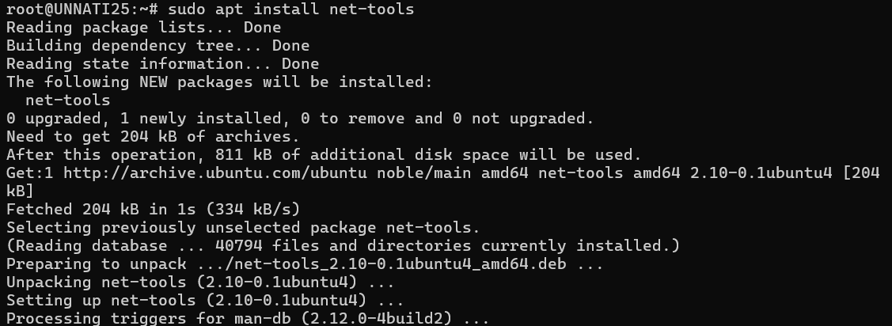

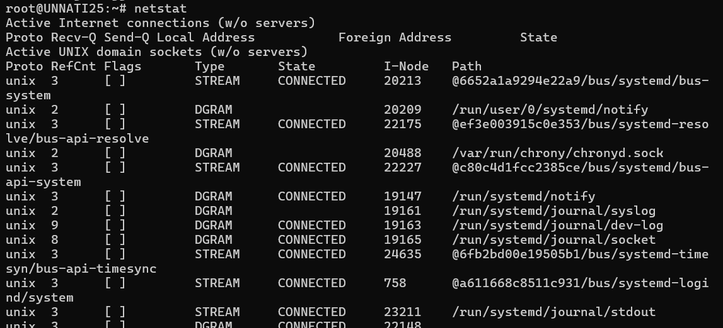

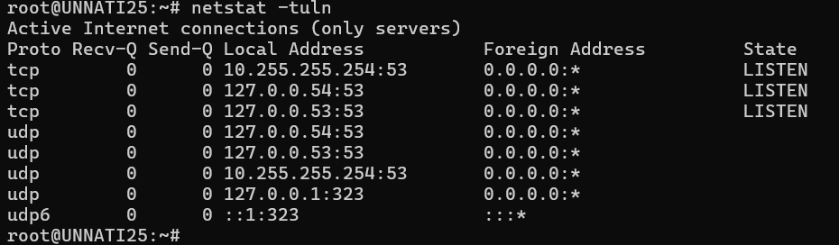

The netstat -tuln command lists all active network connections and listening ports. It helps in troubleshooting and managing network activity. If netstat isn't installed, it can be added using sudo apt install net-tools.